**JAWAHARLAL NEHRU TECHNOLOGICAL UNIVERSITY HYDERABAD**

**Electrical Distribution Systems (A70226)**

**(Elective-II)**

**IV YEAR B.TECH, EEE-I SEM**

**Objective:**

This course gives the complete knowledge of electrical distribution systems, the design of feeders, substations. It also gives conceptual knowledge on how to determine the performance of a distribution system through its important parameters i.e. voltage drops and power losses and the very important thing that protection of the system by means of protective devices and their co-ordination during the several fault conditions. it also specifies how to improve the voltage profiles and power factors of the system to better value using various voltage control and compensation techniques.

**UNIT-I**

**Introduction & General Concepts:**

**Introduction to distribution systems:** Load modeling and characteristics. Coincidence factor, contribution factor, loss factor - Relationship between the load factor and loss factor.

**Classification of loads:** Residential, commercial, Agricultural and industrial loads and their characteristics.

**UNIT-II**

**Distribution Feeders & Substations:**

**Design consideration of Feeders:** Radial and loop types of primary feeders, voltage levels, feeder loading, basic design practice of the secondary distribution system.

**Substations:** Rating of distribution substation, service area within primary feeders. Benefits derived through optimal location of substations.

**UNIT-III**

**Distribution System Analysis:**

**Voltage droop and power-loss calculations:** Derivation for voltage droop and power loss in lines, manual methods of solution for radial networks, three phase balanced primary lines.

**UNIT-IV**

**Protective Devices & Co-Ordination:**

Objectives of distribution system protection , types of common faults and procedure for fault calculations.

**Protective Devices:** Principle of operation of fuses, circuit re-closures and line sectionalizes and circuit breakers.

**Co-Ordination of Protective Devices:** General coordination procedure.

**UNIT-V**

**Voltage Control & P.F Improvement:** Equipment for voltage control effect of series capacitors, line drop compensation effect of AVB/AVR. power factor control using different types of power capacitors, shunt and series capacitors, effect of shunt capacitors (Fixed and Switched), capacitor allocation - Economic justification - Procedure to determine the best capacitor location.

**TEXT BOOK:**

1. Electrical power distribution systems, V.Kamaraju, TMH.

2. Electrical distribution systems. Dr. S. Siva naga raju, Dr. K. Shankar, Danapathi Rai Publications.

**REFERENCE BOOK:**

1. Electrical power Distribution Systems Engineering, Turan Gonen, CRC Press.

2. Electrical power Generation, Transmission and Distribution SN. Singh, PHI Publishers.

**Outcome:**

After going through this course the student gets a thorough knowledge on general aspects of electrical distribution systems, design and analysis of distribution feeders and substations, distribution systems analysis through voltage drop and power loss calculations, operation of protective devices used in distribution systems and their co-ordination, voltage control and power factor improvement through capacitor compensation and distribution system faults analysis with which he/she can able to apply the above conceptual things to real-world electrical and electronics problems and applications.

**UNIT-I**

**INTRODUCTION & GENERAL CONCEPTS**

**Introduction to Distribution Systems**

**Introduction**

The electric utility industry was born in 1882 when the first electric power station, Pearl Street Electric Station in New York City, went into operation. The electric utility industry grew very rapidly, and generation stations and transmission and distribution networks have spread across the entire country. Considering the energy needs and available fuels that are forecasted for the next century, energy is expected to be increasingly converted to electricity.

In general, the definition of an electric power system includes a generating, a transmission, and a distribution system. In the past, the distribution system, on a national average, was estimated to be roughly equal in capital investment to the generation facilities, and together they represented over 80% of the total system investment.

**Distribution System Planning**

System planning is essential to assure that the growing demand for electricity can be satisfied by distribution system additions that are both technically adequate and reasonably economical. Even though considerable work has been done in the past on the application of some types of systematic approach to generation and transmission system planning, its application to distribution system planning has unfortunately been somewhat neglected.

The objective of distribution system planning is to assure that the growing demand for electricity, in terms of increasing growth rates and high load densities, can be satisfied in an optimum way by additional distribution systems, from the secondary conductors through the bulk power substations, which are both technically adequate and reasonably economical.

Distribution system planners must determine the load magnitude and its geographic location. Then the distribution substations must be placed and sized in such a way as to serve the load at maximum cost effectiveness by minimizing feeder losses and construction costs, while considering the constraints of service reliability.

**Factors Affecting System Planning**

**Load Forecasting**

The load growth of the geographic area served by a utility company is the most important factor influencing the expansion of the distribution system. Therefore, forecasting of load increases and system reaction to these increases is essential to the planning process.

Figure 1.1 indicates some of the factors that influence the load forecast. As one would expect, load growth is very much dependent on the community and its development. Economic indicators, demographic data, and official land use plans all serve as raw input to the forecast procedure.

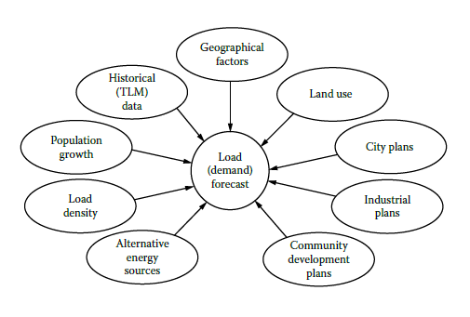

Figure 1.1 Factors affecting load forecast.

**Substation Expansion**

Figure 1.2 presents some of the factors affecting the substation expansion. The planner makes a decision based on tangible or intangible information. For example, the forecasted load, load density, and load growth may require a substation expansion or a new substation construction. In the system expansion plan, the present system configuration, capacity, and the forecasted loads can play major roles.

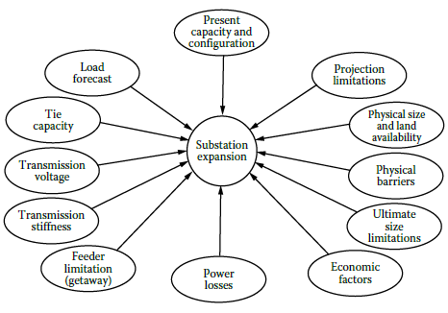

Figure 1.2 Factors affecting substation expansion.

**Substation Site Selection**

Figure 1.3 shows the factors that affect substation site selection. The distance from the load centers and from the existing sub transmission lines as well as other limitations, such as availability of land, its cost, and land use regulations, is important. The substation siting process can be described as a screening procedure through which all possible locations for a site are passed, as indicated in Figure 1.4. The service region is the area under evaluation. It may be defined as the service territory of the utility.

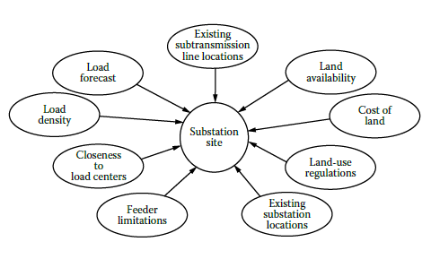

Figure 1.3 Factors affecting substation siting.

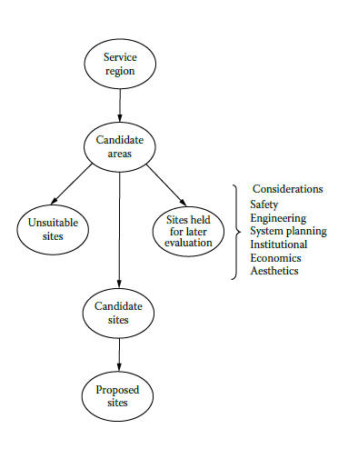

Figure 1.4 Substation site selection procedure.

**Other Factors**

Once the load assignments to the substations are determined, then the remaining factors affecting

primary voltage selection, feeder route selection, number of feeders, conductor size selection, and total cost, as shown in Figure 1.5, need to be considered.

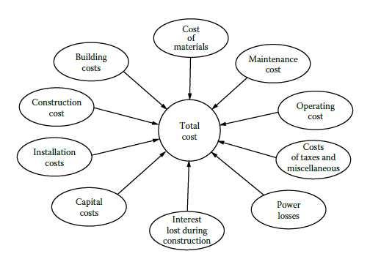

Figure 1.5 Factors affecting total cost of the distribution system expansion.

**Present Distribution System Planning Techniques**

Today, many electric distribution system planners in the industry utilize computer programs,

usually based on ad hoc techniques, such as load flow programs, radial or loop load flow programs, short-circuit and fault-current calculation programs, voltage drop calculation programs, and total system impedance calculation programs, as well as other tools such as load forecasting, voltage regulation, regulator setting, capacitor planning, reliability, and optimal siting and sizing algorithms. Figure 1.6 shows a functional block diagram of the distribution system planning process currently followed by most of the utilities.

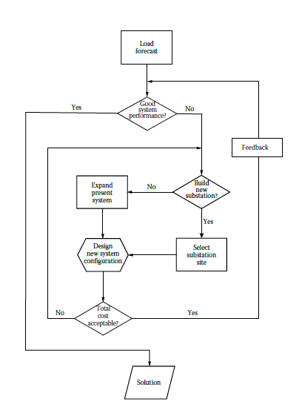

Figure 1.6 A block diagram of a typical distribution system planning process.

The acceptability criteria, representing the company’s policies, obligations to the consumers, and additional constraints, can include

1. Service continuity

2. The maximum allowable peak-load voltage drop to the most remote customer on the secondary

3. The maximum allowable voltage dip occasioned by the starting of a motor of specified starting current characteristics at the most remote point on the secondary

4. The maximum allowable peak load

5. Service reliability

6. Power losses

**Distribution System Planning Models**

In general, distribution system planning dictates a complex procedure due to a large number of variables involved and the difficult task of the mathematical presentation of numerous requirements and limitations specified by system configuration. Therefore, mathematical models are developed to represent the system and can be employed by distribution system planners to investigate and determine optimum expansion patterns or alternatives, for example, by selecting

1. Optimum substation locations

2. Optimum substation expansions

3. Optimum substation transformer sizes

4. Optimum load transfers between substations and demand centers

5. Optimum feeder routes and sizes to supply the given loads subject to numerous constraints to minimize the present worth of the total costs involved.

Some of the operations research techniques used in performing this task include

1. The alternative-policy method, by which a few alternative policies are compared and the best one is selected

2. The decomposition method, in which a large problem is subdivided into several small problems and each one is solved separately

3. The linear-programming, integer-programming, and mixed-integer programming methods that linearize constraint conditions

4. The quadratic programming method

5. The dynamic-programming method

6. Genetic algorithms method

**LOAD CHARACTERISTICS**

**Demand:** “The demand of an installation or system is the load at the receiving terminals averaged over a specified interval of time”. Here, the load may be given in kilowatts, kilovars, kilovoltamperes, kiloamperes, or amperes.

**Demand interval:** It is the period over which the load is averaged. This selected Δt period may be 15 min, 30 min, 1 h, or even longer. Of course, there may be situations where the 15 and 30 min demands are identical

**Maximum demand:** “The maximum demand of an installation or system is the greatest of all demands which have occurred during the specified period of time”. The maximum demand statement should also express the demand interval used to measure it. For example, the specific demand might be the maximum of all demands such as daily, weekly, monthly, or annual.

**Diversified demand (or coincident demand):** It is the demand of the composite group, as a whole, of somewhat unrelated loads over a specified period of time. Here, the maximum diversified demand has an importance. It is the maximum sum of the contributions of the individual demands to the diversified demand over a specific time interval.

**Utilization factor:** It is “the ratio of the maximum demand of a system to the rated capacity of the system”. Therefore, the utilization factor ($F_{u}$) is

$$F_{u}≜\frac{Maximum demand}{Rated systemcapacity}$$

**Plant factor:** It is the ratio of the total actual energy produced or served over a designated period of time to the energy that would have been produced or served if the plant (or unit) had operated continuously at maximum rating. It is also known as the capacity factor or the use factor.

$$Plant factor=\frac{Actual energy produced or served *T}{Maximumplant rating*T}$$

$$Annual Plant factor=\frac{Actual annual energy generation}{Maximum plant rating*8760}$$

**Load factor:** It is “the ratio of the average load over a designated period of time to the peak load occurring on that period”. Therefore, the load factor $F_{LD}$ is o average load.

$$F_{LD}≜\frac{Average load}{Peak load}$$

$$Annual load factor=\frac{Total annual energy}{Annual peak load* 8760}$$

**Diversity factor:** It is “the ratio of the sum of the individual maximum demands of the various subdivisions of a system to the maximum demand of the whole system”. Therefore, the diversity factor (FD) is

$$F_{D}≜\frac{Sumof individual maximum demands}{Coincident maximum demand}$$

$$F_{D}=\frac{\sum_{i=1}^{n}{D_{i}}}{D_{g}}$$

where

$D_{i}$ is the maximum demand of load i, disregarding time of occurrence

$D_{g}=D_{1+2+3+…+n}=$ coincident maximum demand of group of loads

**Coincidence factor:** It is “the ratio of the maximum coincident total demand of a group of consumers to the sum of the maximum power demands of individual consumers comprising the group both taken at the same point of supply for the same time”. Therefore, the coincidence factor (Fc) is

$$F_{c}=\frac{Coincident maximum demand}{Sumof individual maximum demands}$$

$$F_{c}=\frac{D_{g}}{\sum_{i=1}^{n}{D_{i}}}$$

$$F_{c}=\frac{1}{F_{D}}$$

**Load diversity:** It is “the difference between the sum of the peaks of two or more individual loads and the peak of the combined load”. Therefore, the load diversity (LD) is

$$LD≜\left(\sum_{i=1}^{n}{D_{i}}\right)-D_{g}$$

**Contribution factor:** Manning defines ci as “the contribution factor of the ith load to the group maximum demand.” It is given in per unit of the individual maximum demand of the ith load. Therefore,

$$D_{g}≜c_{1}*D_{1}+c_{1}*D_{2}+c_{3}*D_{3}+…+c_{n}*D_{n}$$

if $C=c_{1}=c_{2}….=c_{n}$

$$D_{g}≜C\left(\sum_{i=1}^{n}{D_{i}}\right)$$

Coincidence factor is

$$F_{c}=\frac{D_{g}}{\sum_{i=1}^{n}{D_{i}}}$$

$$F_{c}=C$$

That is, the coincidence factor is equal to the contribution factor.

**Loss factor:** It is “the ratio of the average power loss to the peak-load power loss during a specified period of time”. Therefore, the loss factor (FLS) is

$$F_{LS}≜\frac{Average power loss}{Power lossat peak load}$$

Note: is applicable for the copper losses of the system but not for the iron losses.

**RELATIONSHIP BETWEEN THE LOAD AND LOSS FACTORS**

In general, the loss factor cannot be determined from the load factor. However, the limiting values of the relationship can be found. Assume that the primary feeder shown in Figure 1.8 is connected to a variable load. Figure 1.9 shows an arbitrary and idealized load curve. However, it does not represent a daily load curve.

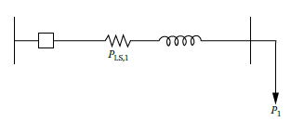

Figure 1.8 A feeder with a variable load.

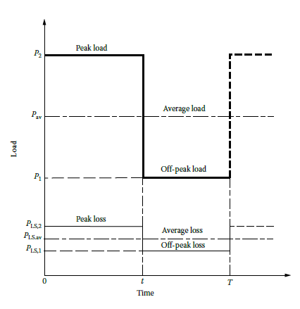

Figure 1.9 An arbitrary and ideal load curve.

Assume that the off-peak loss is $P_{LS,1}$ at some off-peak load $P_{1}$ and that the peak loss is $P_{LS,2}$ at the peak load $P_{2}$. The load factor is

$$F_{LD}≜\frac{Average load}{Peak load}=\frac{P_{av}}{P_{2}}$$

From Figure 2.9

$$P_{av}=\frac{P_{2}*t+P_{1}*(T-t)}{T}$$

form that

$$F_{LD}=\frac{t}{T}+\left(\frac{P_{1}}{P_{2}}*\frac{(T-t)}{T}\right)$$

The loss factor is

$$F_{LS}≜\frac{Average power loss}{Power lossat peak load}=\frac{P_{LS,av}}{P_{LS,max}}=\frac{P_{LS,av}}{P_{LS,2}}$$

From Figure 2.9,

$$P_{LS,av}=\frac{P_{LS,2}*t+P_{LS,1}*(T-t)}{T}$$

from that $$F_{LS}=\frac{t}{T}+\left(\frac{P_{LS,1}}{P_{LS,2}}*\frac{(T-t)}{T}\right)$$

The copper losses are the function of the associated loads. Therefore, the off-peak and peak loads

can be expressed, respectively, as

$$P_{LS,1}=k*P_{1}^{2}$$

and $$P_{LS,2}=k*P_{2}^{2}$$

so that $$F_{LS}=\frac{t}{T}+\left({\left(\frac{P_{1}}{P_{2}}\right)}^{2}*\frac{(T-t)}{T}\right)$$

The load factor can be related to loss factor for three different cases.

**Case 1:** Off-peak load is zero. Here $P_{LS,1}=0$ since $P_{1}$ = 0.

then

$$F_{LD}=F_{LS}=\frac{t}{T}$$

That is, the load factor is equal to the loss factor, and they are equal to the $\frac{t}{T}$ constant.

**Case 2:** Very short-lasting peak. Here,

t=0 then

$$\frac{\left(T-t\right)}{T}=1$$

$$F_{LS}={F_{LD}}^{2}$$

That is, the value of the loss factor approaches the value of the load factor squared.

**Case 3:** Load is steady. Here,

t=T then

$$F_{LD}=F_{LS}$$

That is, the value of the loss factor approaches the value of the load factor.

Therefore, in general, the value of the loss factor is

$${F_{LD}}^{2}<F_{LS}<F_{LD}$$

Therefore, the loss factor cannot be determined directly from the load factor. The reason is that the loss factor is determined from losses as a function of time, which, in turn, are proportional to the time function of the square load.

However, Buller and Woodrow developed an approximate formula to relate the loss factor to

the load factor as

$$F_{LS}=0.3F_{LD}+0.7{F_{LD}}^{2}$$

Figure 1.10 gives three different curves of loss factor as a function of load factor. Relatively recently, the formula given earlier has been modified for rural areas.

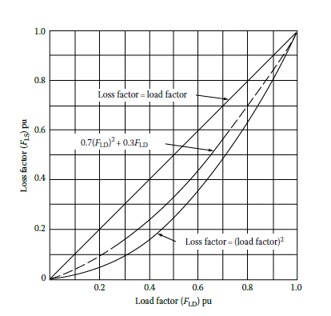

Figure 1.10 Loss factor curves as a function of load factor. (From Westinghouse Electric Corporation, Electric Utility Engineering Reference Book-Distribution Systems, Vol. 3, Westinghouse Electric Corporation, East Pittsburgh, PA, 1965.)

**CLASSIFICATION OF LOADS**

A device which taps electrical energy from the electric power system is called a load on the system. The load may be resistive (e.g., electric lamp), inductive (e.g., induction motor), capacitive or some combination of them. The various types of loads on the power system are

* Residential Loads
* Commercial Loads
* Agricultural Loads
* Industrial Loads

**Residential Loads/ Domestic Loads**

Residential Loads or Domestic load consists of lights, fans, refrigerators, heaters, television, small motors for pumping water etc. Most of the residential load occurs only for some hours during the day (i.e., 24 hours) e.g., lighting load occurs during night time and domestic appliance load occurs for only a few hours. For this reason, the load factor is low (10% to 12%).

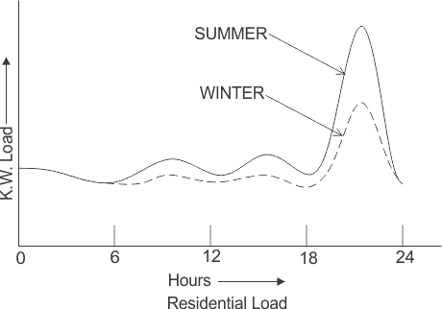

**Commercial Loads**

Commercial load consists of lighting for shops, fans and electric appliances used in restaurants etc. This class of load occurs for more hours during the day as compared to the domestic load. The commercial load has seasonal variations due to the extensive use of airconditioners and space heaters.

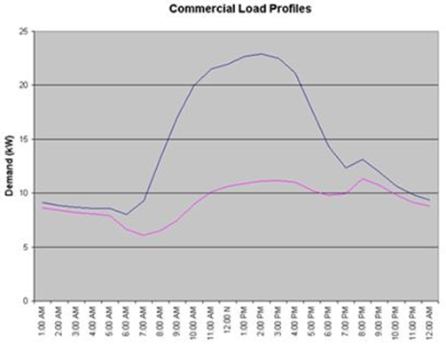

**Agricultural Loads/ Irrigation Loads** 

This type of load is the electric power needed for pumps driven by motors to supply water to fields. Generally this type of load is supplied for 12 hours.

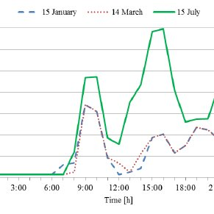

**Industrial Loads**

Industrial load consists of load demand by industries. The magnitude of industrial load depends upon the type of industry. Thus small scale industry requires load upto 25 kW, medium scale industry between 25kW and 100 kW and large-scale industry requires load above 500 kW. Industrial loads are generally not weather dependent.

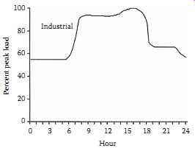

**Municipal load:** Municipal load consists of street lighting, power required for water supply and drainage purposes. Street lighting load is practically constant throughout the hours of the night. For water supply, water is pumped to overhead tanks by pumps driven by electric motors. Pumping is carried out during the off-peak period, usually occurring during the night. This helps to improve the load factor of the power system.

**Traction load:** This type of load includes tram cars, railways etc. This class of load has wide variation. During the morning hour, it reaches peak value because people have to go to their work place. After morning hours, the load starts decreasing and again rises during evening since the people start coming to their homes.

**UNIT-II**

**DISTRIBUTION FEEDERS & SUBSTATIONS**

The part of the electric utility system that is between the distribution substation and the distribution transformers is called the primary system. It is made of circuits known as primary feeders or primary distribution feeders. Figure 2.1 shows a one-line diagram of a typical primary distribution feeder. A feeder includes a “main” or main feeder, which usually is a three-phase four-wire circuit, and branches or laterals, which usually are single-phase or three-phase circuits tapped off the main. Also sublaterals may be tapped off the laterals as necessary. In general, laterals and sublaterals located in residential and rural areas are single phase and consist of one-phase conductor and the neutral. The majority of the distribution transformers are single phase and are connected between the phase and the neutral through fuse cutouts. There are various and yet interrelated factors affecting the selection of a primary-feeder rating. Examples are

1. The nature of the load connected

2. The load density of the area served

3. The growth rate of the load

4. The need for providing spare capacity for emergency operations

5. The type and cost of circuit construction employed

6. The design and capacity of the substation involved

7. The type of regulating equipment used

8. The quality of service required

9. The continuity of service required

The voltage conditions on distribution systems can be improved by using shunt capacitors that are connected as near the loads as possible to derive the greatest benefit.

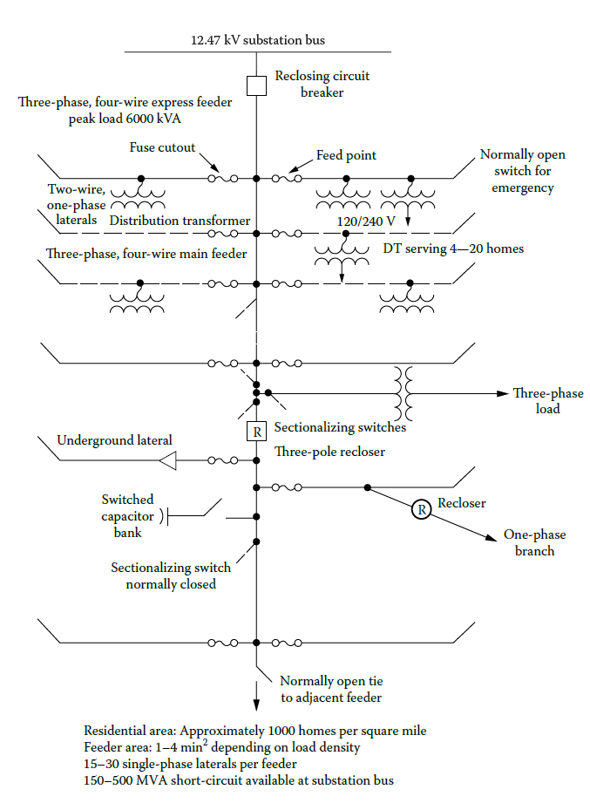

**Figure 2.1** One-line diagram of typical primary distribution feeders. (From Fink, D.G. and Beaty, H.W., Standard Handbook for Electrical Engineers, 11th edn., McGraw-Hill, New York, 1978.).

**Radial-Type Primary Feeder**

The simplest and the lowest cost and therefore the most common form of primary feeder is the radial-type primary feeder as shown in Figure 2.2. The main primary feeder branches into various primary laterals that in turn separates into several sublaterals to serve all the distribution transformers.

In general, the main feeder and subfeeders are three-phase three- or four-wire circuits and the laterals are three phase or single phase. The current magnitude is the greatest in the circuit conductors that leave the substation. The current magnitude continually lessens out toward the end of the feeder as laterals and sublaterals are tapped off the feeder. Usually, as the current lessens, the size of the feeder conductors is also reduced. However, the permissible voltage regulation may restrict any feeder size reduction, which is based only on the thermal capability, that is, current-carrying capacity, of the feeder.

The reliability of service continuity of the radial primary feeders is low. A fault occurrence at any location on the radial primary feeder causes a power outage for every consumer on the feeder unless the fault can be isolated from the source by a disconnecting device such as a fuse, sectionalizer, disconnect switch, or recloser.

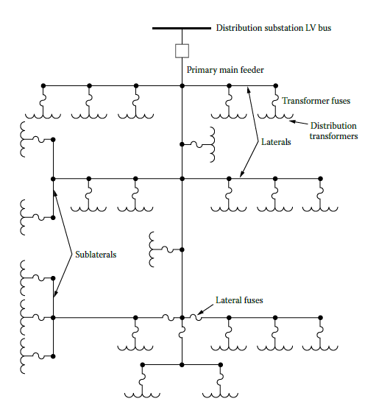

**Figure 2.2** Radial-type primary feeder.

**Radial-type primary feeder with tie and sectionalizing switches**

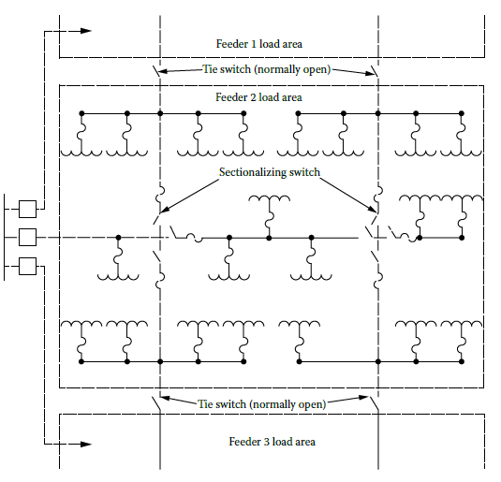

**Figure 2.3** Radial-type primary feeder with tie and sectionalizing switches.

Figure 2.3 shows a modified radial-type primary feeder with tie and sectionalizing switches to provide fast restoration of service to customers by switching unfaulted sections of the feeder to an adjacent primary feeder or feeders. The fault can be isolated by opening the associated disconnecting devices on each side of the faulted section.

**Radial-type primary feeder with express feeder and backfeed**

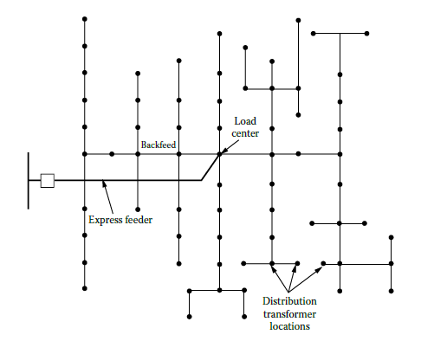

**Figure 2.4** Radial-type primary feeder with express feeder and backfeed.

Figure 2.4 shows another type of radial primary feeder with express feeder and backfeed. The section of the feeder between the substation low-voltage bus and the load center of the service area is called an express feeder. No subfeeders or laterals are allowed to be tapped off the express feeder. However, a subfeeder is allowed to provide a backfeed toward the substation from the load center.

**Radial-type phase-area feeder**

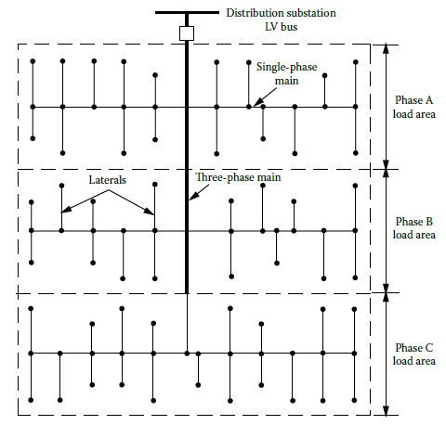

**Figure 2.5** Radial-type phase-area feeder.

Figure 2.5 shows a radial-type phase-area feeder arrangement in which each phase of the three phase feeder serves its own service area.

**Loop-Type Primary Feeder**

Figure 2.6 shows a loop-type primary feeder that loops through the feeder load area and returns back to the bus. Sometimes the loop tie disconnect switch is replaced by a loop tie breaker due to the load conditions. In either case, the loop can function with the tie disconnect switches or breakers normally open (NO) or normally closed. Usually, the size of the feeder conductor is kept the same throughout the loop. It is selected to carry its normal load plus the load of the other half of the loop. This arrangement provides two parallel paths from the substation to the load when the loop is operated with NO tie breakers or disconnect switches.

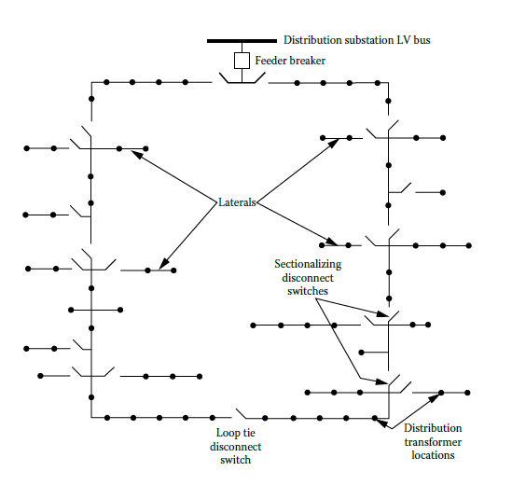

**Figure 2.6** Loop-type primary feeder.

### MESHED SYSTEMS

In transmission and sub-transmission systems, usually **parallel, ring or interconnected (mesh) systems** are used. This ensures that alternative supply can be made to customers in the event of failure of a transmission line or element. The general rule is that where large loads or numbers of customers are involved, then some form of standby, in the form of deliberate redundancy, is built into the network design, through the use of parallel, meshed or ring type feeders.

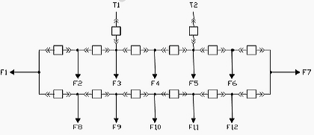

**PARALLEL FEEDERS**

A greater level of reliability at a higher cost is achieved with a parallel feeder. To improve the reliability factor it may be possible to have the separate sets of cables follow different routes. In this case the capital cost is double that of a radial feeder but there is a greater reliability factor for the line. This may be justified if the load is higher, more customers are being supplied, or there are loads such as hospitals which require high levels of reliability

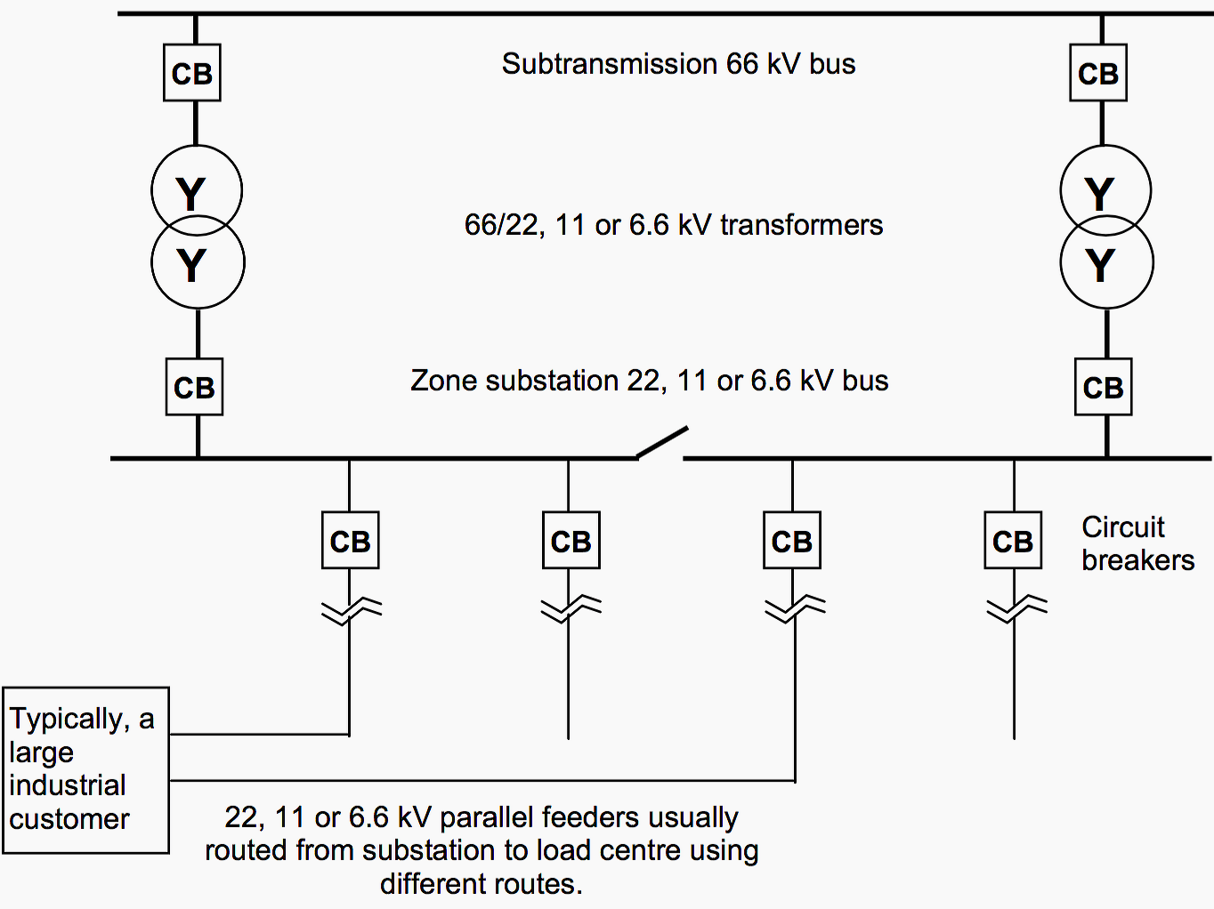

**SECONDARY DISTRIBUTION SYSTEMS**

**Present Design Practice**

The part of the electric utility system that is between the primary system and the consumer’s property is called the secondary system. Secondary distribution systems include step-down distribution transformers, secondary circuits (secondary mains), consumer services (or SDs), and meters to measure consumer energy consumption.

Generally, the secondary distribution systems are designed in single phase for areas of residential customers and in three phase for areas of industrial or commercial customers with high-load densities.

The types of the secondary distribution systems include the following:

1. The separate-service system for each consumer with separate distribution transformer and secondary connection

2. The radial system with a common secondary main, which is supplied by one distribution transformer and feeding a group of consumers

3. The secondary-bank system with a common secondary main that is supplied by several distribution transformers, which are all fed by the same primary feeder

4. The secondary-network system with a common grid-type main that is supplied by a large number of the distribution transformers, which may be connected to various feeders for their supplies

The separate-service system is seldom used and serves the industrial- or rural-type service areas. Generally speaking, most of the secondary systems for serving residential, rural, and light-commercial areas are radial designed. Figure 2.12 shows the one-line diagram of a radial secondary system. It has a low cost and is simple to operate.

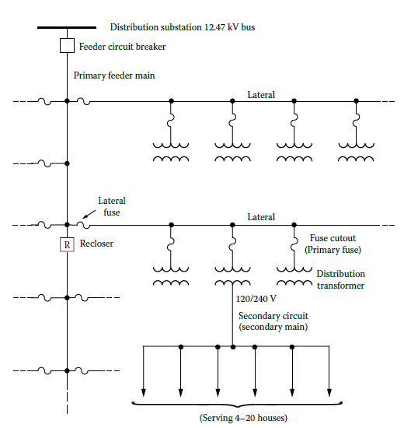

**Figure 2.12** One-line diagram of a simple radial secondary system.